**Java 8 clarifications**

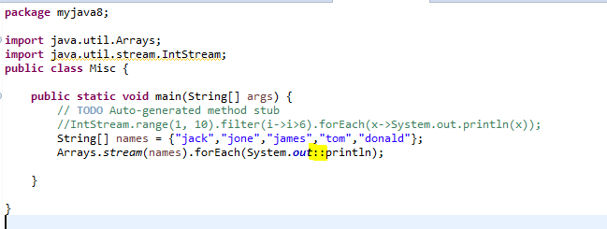

Why double colon is used here? What :: means? Why normal System.out.println not working here.

Try the following:

Stream <String> .

Bands= Files.lines.(Paths.get(filename))